®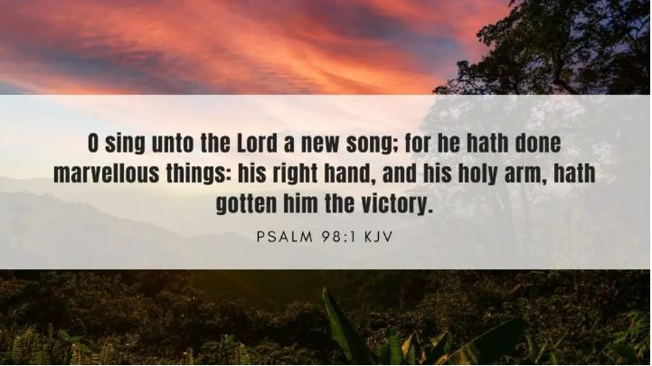

***January 2024***

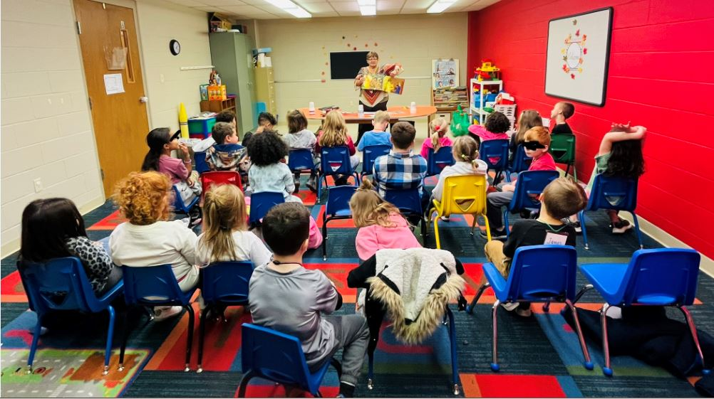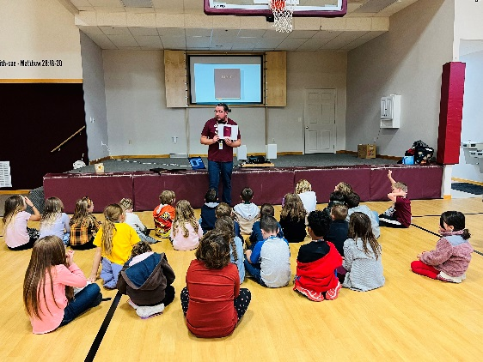

“I love coming to Good News Club! It’s the only place I hear about Jesus,” exclaimed a first grade boy at the Greencastle Good News Club. “This is the best day of my life!” exclaimed a Kindergarten boy as he got off the bus for Good News Club. These are some of the many things we hear from the children we teach. Our 29 Good News Clubs have been going GREAT! Our volunteer teachers pour their hearts and energy into each lesson they prepare. The volunteers are an amazing asset to each club as they usher children and sit among them at GNC™. Bus drivers are a vital part of most clubs because without them the children wouldn’t be able to come! We are always still looking for volunteers to help fill in these positons in Franklin and Fulton County. If you feel led to be a part of this ministry please reach out to Pastor Matt or Tiffanie.

1. Prayer: Each day several Good News Clubs meet. Please be praying for our volunteers, safety on the bus, good behavior, and hearts that are ready to hear the Gospel.

2. We are always in need of extra helpers. We would love to have you visit a club! We especially need help at our Forbes Road Club.

3. Do you have a CDL? We need friendly bus drivers to help take our kids to clubs.

Sarah Brown teaching Kindergarten students from Summitview Elementary

***How you can help a GNC™!***

*“This is the Best Day of My Life!”*

*Good News Club® Update*

*Child Evangelism Fellowship® of Franklin and Fulton Counties*

***lmpact***

It is hard to believe that camp preparations will start to be underway this month! Camp t-shirts will be designed and ordered, brochures will be revised, and camp crafts will be ordered, just to name a few! Teacher letters will be sent out next month, so start planning what week you would like to teach at camp! We would love to have you be a part of our summer staff. You will have the unique opportunity to share the hope of the Gospel with countless boys and girls! Let us know if you would like to join us this summer!

In December, the CEF® Committee had the privilege of honoring Dr. Dan and Michelle for their many years of service with a catered Chick-fil-A meal. The Russells were also presented with a 2-night stay trip and a large gift bag of many cards from so many of you. Thank you for being a blessing to them. We know they appreciated it. The Russells have been an amazing blessing to us over the last few months. We would still covet your prayers as we begin the New Year without them. We look forward to serving the Lord and you all as well.

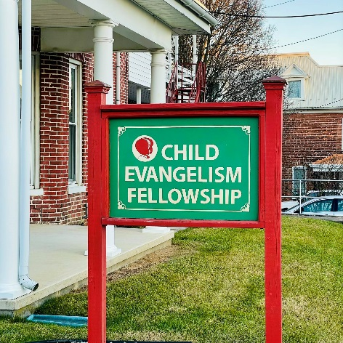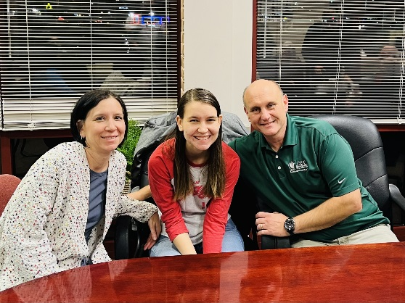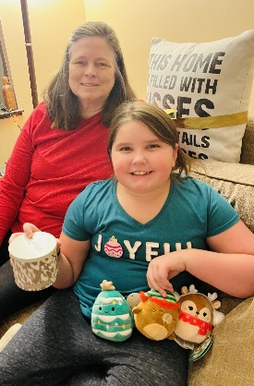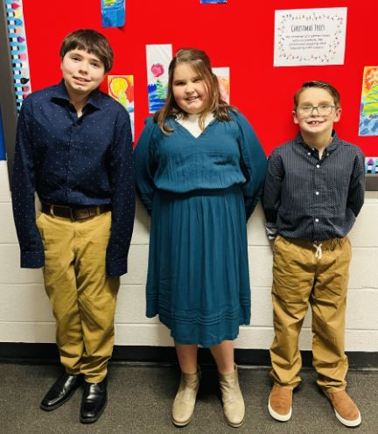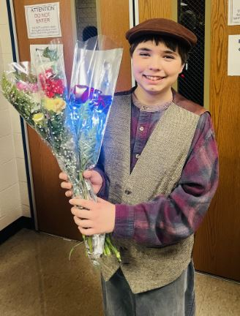

We have ‘revamped’ our Facebook page. You can now find us at “CEF of Franklin and Fulton Counties.” We will be posting weekly information, devotions, verses, link to the CEF Unite® Channel, and more! Give us a “like.”

Matt and Tiffanie Robinson Coordinator and Co-Cordinator

Lori Schroder – Office Manager Nathan Egolf – Field Worker

Stephen Burdette – Field Worker

PO Box 6, Waynesboro, PA 17268

Office: (717) 762-2115

45 S Broad Street, Waynesboro 17268

Email: [cefoffice@franklincef.com](mailto:cefoffice@franklincef.com)

Website: [www.franklincef.com](http://www.franklincef.com/)

*Contact us!*

*Social Media!*

All three kids sang in the Christmas program at their school. Titus was super excited about this program because his class played “Boom Whackers” with a Christmas carol. Boom Whackers are plastic tubes that the children hit on the stage and somehow each color of boom whacker plays a different note. He felt like big stuff playing his “first instrument.”

Maggie’s excitement from December was traveling to Ohio for a daytrip baby shower with her mom, aunt, and grandma. Maggie LOVES babies and is very excited to get a new baby cousin around the first of the year! The even greater excitement is the gender and name of the baby has not been revealed- so lots to look forward to! Oh, and side note, somehow Maggie won the most prizes from the games out of everyone!

Noah’s highlight from December was his performance in Beauty and the Beast with Waynesboro Community Theatre Troupe. Between the four shows he played three roles: a crony (friend of Gaston’s), a book seller, and D’arque. Along with speaking parts, he even had a few solo lines to sing! He had several practices a week for several months. It was a lot of hard work! He absolutely loved it and looks forward to doing another production with them next year.

*The Robin’s Nest*

Option congue nihil imperdiet doming id quod mazim placerat facer minim veni am ut wisi enim ad minimeniam, quis erat nostr uexerci tation ullamcorper nostru exerci tation ullam corper et iusto odio dig nissim qui blandit praesent lupta. Tummer delenit augue duis dolore te feugait nulla facilisi.

Con erattis sectetuer adip iscing elit, sed erat diam nonummy nibh magna erat aliquam erat volutpat. Nam liber tempor cum soluta nobis sed diam nonummy nibh ut wisi enim ad minim veni am, quis nostruexerci tation ullam corper.

Option congue nihil imperdiet doming id quod mazim placerat facer minim veni am utte wisi enim ad minimeniam, quis nostr uexerci tation ullamcorer. Nostru exerci tation ullam corper et iusto odio dig nissim qui blandit praesent lupta tum delenit augue duis dolore terra feugait. Option congue nihil imperdiet doming id quod mazim pla

cerat facer minim veni am ut wisi enim ad minimeniam, quis erat nostr uexerci tation ullamcorper nostru exerci tation ullam co

rper et iusto odio dig nissim qui blandit.

*Option congue nihil imperdiet doming id quod mazim placerat facer minim ve*

*ni am ut wisi enim ad minimeniam, quis erat nostr uexerci tation ullamcorper nostru exerci tation ullam corper et iusto odio dig nissim qui blandit praesen.*

***ask the experts >>>***

Option congue nihil imperdiet doming id quod mazim placerat facer minim veni am ut wisi enim ad minimeniam, quis erat nostr uexerci tation ullamcorper nostru exerci tation ullam corper et iusto odio dig nissim qui blandit praesent lupta. Tummer delenit augue duis dolore magna erat aliquam erat volutpat. Nam liber tempor cum soluta nobis sed.