**February 2024**

**Child Evangelism Fellowship ® of Franklin and Fulton County**

**Impact**

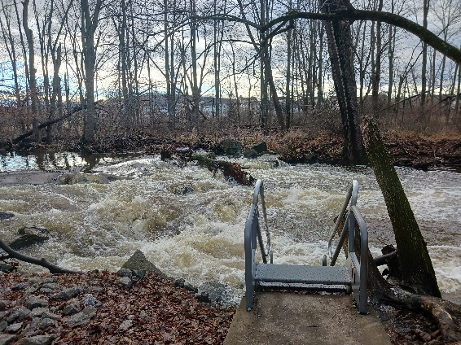

What more could we need? We could always use more quality teachers, helpers, junior staff, etc. The majority of the children that attend camp are unchurched and unsaved. They need the Gospel, but they need someone to tell them. Could you be that person who will introduce a child to Christ?

*“The harvest is plenteous, but the laborers are few. Pray…., that he will send forth labourers into his harvest” Matthew 9:37-38*

We have been meeting with our camp staff to build plans for an exciting, Christ-honoring summer. We are blessed with a phenomenal staff! This summer’s theme is “SUPERHEROES!” The lessons will focus on the “I Am” statements of Jesus from John’s Gospel account. We are excited to teach these lessons to little hearts! We have also been blessed with multiple donations for campers to come this summer! In a few months we anticipate around 1300 boys and girls to be splashing in this pond. We look forward to them quoting their verses, singing about God, and learning about Jesus from the Bible. We are also meeting with the graphic art company to design this summer’s t-shirt. What do you think the design will be?

The picture above isn’t a typical memory of camp for most people. To be honest, a frozen pond in the middle of those muggy 100° days of July might be a bit refreshing. Typically we only think about camp during those warm days of summer, but camp is never just a future thought; it’s presently on our mind. We have been busily maintaining the camp each week. The past few weeks of high winds have caused quite a mess. We lost multiple trees, but thankfully the current of the creek washed most of them downstream. The snow has made the camp beautiful, attracting lots of deer and other wildlife, but has also caused the ground to be quite soggy.

**“Getting Geared Up”**

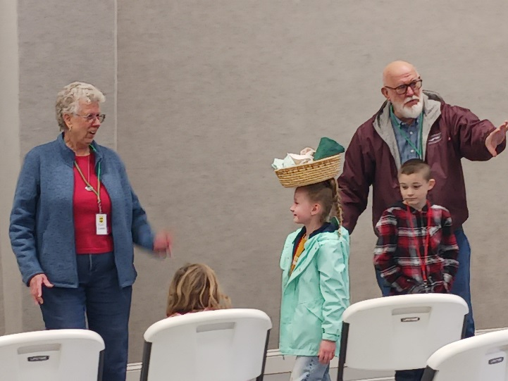

Teachers, Dave and Eileen, from the Lurgan GNC taught about missionaries from Haiti. The children were able to practice how the people in Haiti would carry baskets on their heads. This was a hit among the children!

Social Media

Don’t forget that we have refreshed our social media. Look us up at CEF Franklin and Fulton County on Facebook. We are regularly sharing updates, meetings, teacher tips, Unite Videos ®, devotions, and more.

Online Giving

We have created an online plaform to make giving easier. Feel free to contact the office to find out more. Here is the website for the online giving  
https://franklincef.breezechms.com/give/online

Contact us:

Matt and Tiffanie Robinson Coordinator and Co-Cordinator

[pastormattcef@gmail.com](mailto:pastormattcef@gmail.com)

240-625-0056

Lori Schroder - Office Manager

Nathan Egolf- Field Worker

Stephen Burdette – Field Worker

PO Box 6, Waynesboro, PA 17268

Office: (717) 762-2115

45 S Broad Street, Waynesboro, PA 17268

Email: cefoffice@franklincef.com

website: www.franklincef.com

Our most recent teacher training session focused on two major themes: the fear of change and how to provide a child with the assurance of salvation. We are thankful for our FANTASTIC volunteers who come out to these meetings. The goal of these meetings is to invest into our teachers and helpers by providing tips, games, fellowship, updates, and encouragment.

If you missed January’s Teacher Training and would like the Snowflake Zonk game that was given away, contact the office or the Robinsons and we would be happy to get you a game to use in your teaching setting! Our next teacher training will be on **February 5th (Chambersburg Bible, 9:30) and 6th (CEF office 9:30, 7:00).** Our friend Diane Pomroy will be sharing at this meeting. We would LOVE to see you!

Teacher Training

A Shepherd can point these children to Christ and tell them how He can be the mender of their hearts. The Shepherd points kids to the Way, the Truth, and the Life. When a Shepherd leaves a Good News Club their “job” for the day is done, but they spend the rest of the week praying for those precious little ones. Our Shepherds tirelessly care for the children. Please be praying for them each week as they share the Gospel.

The role of the Shepherd in a GNC is just like that of a real shepherd- to oversee and care for the sheep. The Shepherds in our clubs pull aside 1-3 children at a time and counsel them in sight of other workers to see where they stand spiritually. This is a time when the gospel is shared, the child is asked what they have been learning in clubs, and if they have a relationship with Jesus. This is an excellent time to understand where a child stands spiritually and how the Shepherd can be praying.

Good News Clubs® are still going splendid! We truly have the best staff and are so honored when someone is willing to give up time from their busy week to come assist in various ways at a GNC™. As always, we appreciate your prayers each day for the big undertaking these clubs are in operation, from the teachers preparing lessons, to helpers assisting, to bus drivers driving, to students walking to and from clubs/the bus, and to those who are Shepherding.