**April 2024**

**Child Evangelism Fellowship® of Franklin and Fulton County**

**Impact**

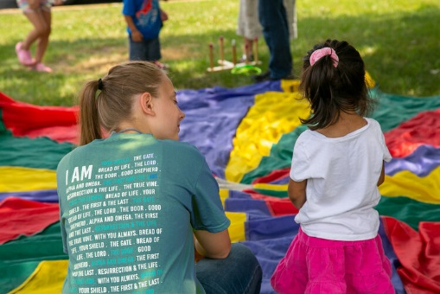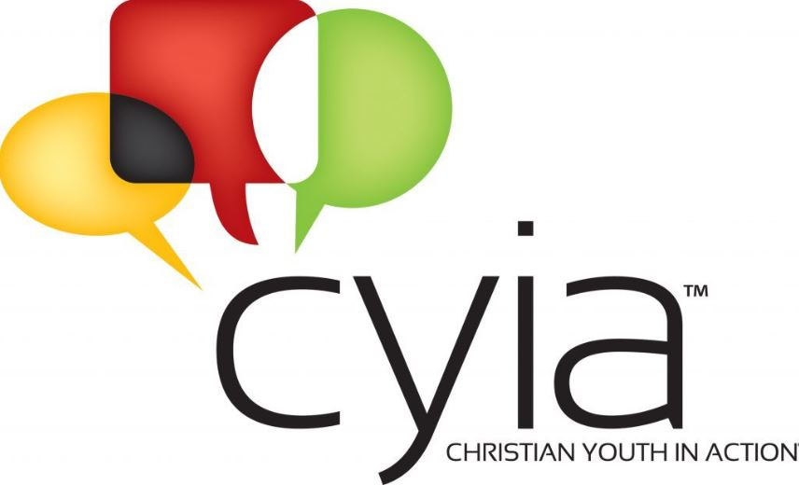

How can you help us in this new adventure? First, pray. Second, invite young people to this life- changing opportunity. Third, be prepared to support them as they take their first steps as summer missionaries. Finally, maybe you would like to like to host a backyard club. Our CYIA missionaries would love to come into your community to hold a 5-Day Club®, teach at a daycare center, visit an apartment complex, or be a part of a community outreach event. Please reach out to the office for more information!

We are praying that God would raise at least six summer missionaries who would be willing to go into local communities (our backyard), churches, daycares, and neighborhoods to share the Gospel with children. Nearly twenty years ago Tiffanie served Jesus as a CYIA summer missionary and says this was the most important decision she has ever made. Her time as a CYIA missionary changed her heart, cultivated her to serve God, and helped her develop a deep love for children. CYIA trains young people to share their faith, develop teamwork, create lifelong friendships, and to grow to know Christ better. What a rewarding summer!!!

We are SO excited to relaunch a ministry opportunity. *Christian Youth In Action®*(*CYIA*) provides students ages fifteen and up a way to make an eternal impact in the lives of children in their state. *CYIA* is a program designed to train young people in effective and engaging ways to teach children about God. They will attend a one-week training school in Somerset and another week of training locally. They will learn to present the Gospel clearly on a child’s level, counsel a child for salvation, and lead a dynamic club ministry for kids. Components of this club include teaching a Bible lesson, a real-life missionary story and a Bible verse as well as leading songs, games and a fun review time. We have recently hired Gina Roche to be our CYIA coordinator. Gina is no stranger to CEF. She has been faithfully working in our area for over 20 years. Gina is an extremely gifted teacher and leader. She will be a great asset to this ministry as we progress forward.

Exciting Opportunity!

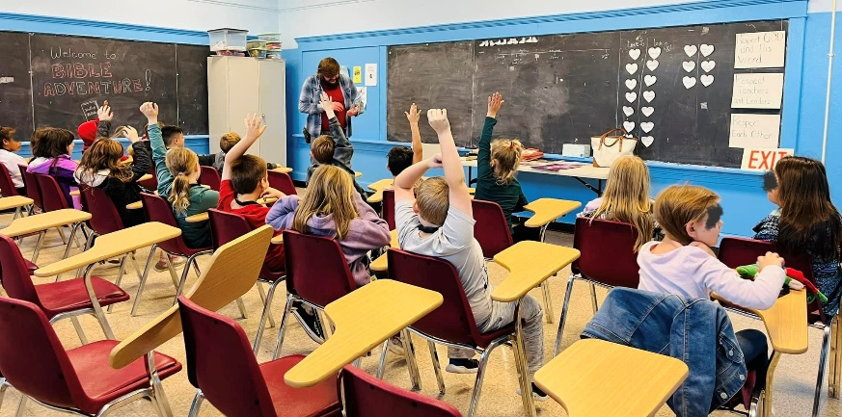

**Social Media**

Look us up at CEF® Franklin and Fulton County on Facebook. We are sharing updates, meetings, teacher tips, U-nite®, videos, devotions, and more.

We have also created an online plaform to make giving easier. Here is the website for the online giving:  
<https://franklincef.breezechms.com/give/online>

**QR Code for Camp**

**Contact us:**

Matt and Tiffanie Robinson Coordinator and Co-Cordinator

[pastormattcef@gmail.com](mailto:pastormattcef@gmail.com)

240-625-0056

Lori Schroder - Office Manager

Nathan Egolf- Field Worker

Stephen Burdette – Field Worker

PO Box 6, Waynesboro, PA 17268

Office: (717) 762-2115

45 S Broad Street, Waynesboro, PA 17268

Email: cefoffice@franklincef.com

website: www.franklincef.com



The children will be receiving information to take home to continue their spiritual growth. They will find out about summer camp, Mailbox Club, call our Tell-a-Story® phone number, join in family-friendly fun on the CEF U-Nite channel, and more. Our second graders will be receiving a Bible so they can learn more about Christ at home. Pray for these precious little ones. For many of them, Clubs are their only connection to Christ.

**Good News Clubs®**

**Friday, May 3rd at Camp, 6-7 PM**

**Saturday, May 18th at Camp, 10-11AM**

Good News Camp

Good News Camp is quickly approaching! We have already been receiving registration forms and camp staff applications. If you are interested in sending your child to camp please go to [www.franklincef.com](http://www.franklincef.com) or use the QR code on this letter!

We want to introduce our latest t-shirt. This beautiful green shirt has our iconic wood name tag. Think of all the precious children who will be wearing not just the shirt, but name tags, too!

We are also planning **junior counselor training**. To be a counselor at camp you must have finished 8th grade, served at least one week as a helper, and attend one of our training meetings. Our meetings will be:

How are we able to share the Good News at so many clubs and with so many children? First, because of God’s amazing faithfulness, and second, because of dedicated volunteers. We have hundreds of volunteers who share the message of Christ to children.

So far 129 children have made professions of faith! Read that number one more time. That’s a lot of rejoicing in heaven! I hope that causes you to rejoice too!

The clock is quickly winding down on our Good News Clubs for the year. Most of our clubs will be ending at the end of March/start of April. I wanted to share a few numbers with you regarding clubs. We were able to facilitate a club for each elementary school in our district. This is nothing short of miraculous. There are over 79 different teaching clubs (some schools have multiple clubs operating at the same time). That means we have shared the Gospel with 1661 children!

proprius. In consequat os quae nulla magna. Delenit abdo esse quia, te huic. Ratis neque ymo, venio illum pala damnum. Aptent nulla aliquip camur ut consequa.

Aptent. Adipiscing magna   
jumentum velit iriure   
obruo vel.Volutpat mos   
at neque nulla lobortis   
dignissim conventio,   
torqueo, acsi roto modo.   
Feugait in obruo quae ingenium   
tristique elit vel natu meus.